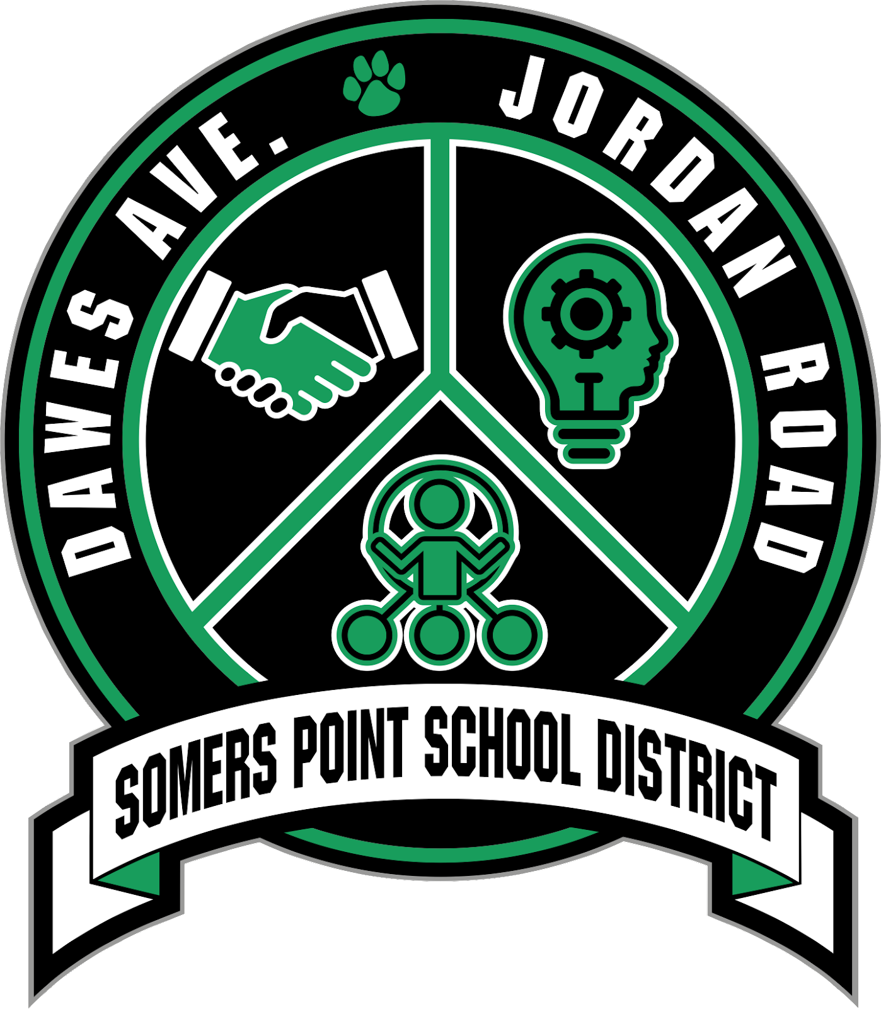
SOMERS POINT SCHOOL DISTRICT
ADMINISTRATION OFFICES
121 West New York Avenue
Somers Point, New Jersey 08244

Phone: (609) 927-2053 ~ Fax: (609) 927-7351 ~ www.sptsd.org
Christopher Kobik, Interim Superintendent Ext: 3211
Mary Conroy, Business Administrator/ Board Secretary Ext: 3220

CHAIN OF COMMAND

HOW TO EFFECTIVELY COMMUNICATE WITH SCHOOL OFFICIALS

- Parents are often discouraged when they attempt to communicate with Central Office administrators and are sent back to building-based officials to resolve a problem their child may be experiencing in school. To prevent that frustration, parents can become informed about the “Chain of Command”, or where to begin the communication sequence. Many parental questions are easily and completely answered by communicating directly with the educator in charge of the class or program. Each situation should first be addressed at whatever level the initial action was taken with appeals moving on to the next level of the chain of command. The easiest way to communicate is via email; email addresses can be found on the Directory page. A phone call would be the next preferable way to communicate.

On Matters Involving Instruction (ALL GRADES)

  - Classroom Teacher
  - Case Manager (If Applicable)
  - School Counselor
  - School Level Administration
    - Jordan Road Middle School
      - Principal Mr. Ted Pugliese (609) 927-7161 Ext. 1157
Secretary, Mrs. Susan Waniak
      - Assistant Principal Mrs. Amanda Winslow (609) 927-7161 Ext. 1158
Secretary, Ms. Patricia Nicodemus
    - Dawes Avenue Elementary School
      - Principal Mrs. Melanie Wagner (609) 653-1027 Ext. 6121
Secretary, Mrs. Amy Hoffman
  - District Level Administration
    - Office of Curriculum & Instruction
      - Director of Curriculum Dr. Laura Venello (609) 927-7161 Ext. 1246
    - Office of Special Services
      - Director of Special Education (Programs/ Services, CST, Speech, Guidance, Teachers, Paraprofessionals, and Related Service Providers - OT and PT)
Dr. Laura Venello, (609) 927-7161 Ext. 1246
Secretary Mrs. Melissa D'Amico

On Matters that involve Section 504's.

- Mr. Joe Schmidt, Jordan Road (jschmidt@sptsd.org)
- Mr. Jim Scarano, Jordan Road (jscarano@sptsd.org)
- Mrs. Julie Antell, Dawes Avenue (jantell@sptsd.org)
- Mrs. Carley Cross, Dawes/ Jordan (ccross@sptsd.org)
- Mrs. Katelyn Tobiasen, Dawes - PreK (ktobisen@sptsd.org)

On Matters Involving Athletics or Extra-Curricular Activities (Middle School)

  - Club Advisor or Coach - (609) 927-7161
  - Athletic/Activities Director (609) 927-7161
    - Activities Director, Mr. Joe Schmidt (609) 927-7161
    - Athletic Director, Mrs. Devon Kallen (609) 927-7161
  - Principals
    - Principal, Jordan Road, Mr. Ted Pugliese, 609) 927-7161 Ext. 1158
      - Secretary, Mrs. Susan Waniak
    - Principal Mrs. Melanie Wagner (609) 653-1027 Ext. 6121
      - Secretary, Mrs. Amy Hoffman

On Matters Involving Student Discipline

  - Classroom Teacher
  - Assistant Principal, Jordan Road, Mrs. Amanda Winslow, (609) 927-7161 Ext. 1157 OR Principal, Jordan Road Mr. Ted Pugliese, (609) 927-7161 Ext. 1158
    - Secretary, Susan Waniak
  - Principal, Dawes Avenue Mrs. Melanie Wagner (609) 653-1027 Ext. 6021
    - Secretary, Amy Hoffman

On Matters Involving Facilities, Building & Grounds (Maintenance/Custodial/Grounds)

  - Principal
  - Director of Facilities, Mr. Keith Nelson (609) 927-7161 Ext. 1159
    - Business Office, Central Office Business Administrator/Board Secretary
Mary Conroy, (609) 927-2053 Ext. 3220
      - Secretary, Mrs. Tina Loder

On Matters Involving Transportation (Central Office)

  - Principal
    - Business Office, Central Office Business Administrator/Board Secretary, Mary Conroy, (609) 927-2053 Ext. 3220
      - Secretary, Mrs. Tina Loder

To Resolve all Matters Only After You Have Followed the Levels Outlined Above (Central Office)

  - Interim-Superintendent of Schools, Mr. Christopher Kobik. (609) 927-2053 Ext. 3211
    - Secretary, Mrs. Dawn Booth

